CVE 311 Fluid Mechanics II (3 Units)
Fluid statics: Floatation and stability. Dynamics of fluid flow-conservation equation of mass and momentum: Euler and Bernoulli equations. Introduction to incompressible viscous flow. Reynold’s Number. Dimensional analysis – Philosophy, Similitude, Buckingham PI theorems. Applications. Hydraulic model. Flow measurements. Flow meters, errors in measurement.

Fluid Statics (Hydrostatics):
Hydrostatics deals with the study of fluids at rest with a focus on the forces acting on the surroundings. The pressure P defined as the force exerted on a unit area of fluid has units in N/m² or bars (10⁵ N/m²), Pressure in the fluid at rest increases with increase in depth of fluid.
For fluid at rest, all forces acting on a body of fluid are in equilibrium i.e. action and reaction forces are perpendicular to boundary surfaces. For fluid in motion, force within body of fluid exhibit a shear component therefore forces are not all perpendicular to boundary surfaces. The only force supporting a column of fluid at rest is force acting upwards as shown in figure 1.
Zero gauge pressure (no water weight above)

Height h
weight

Upward Force

Figure 1: Column of Water with depth h.

Weight of column of water (acting downwards) must be equal to the upward force:
Specific Weight of water = ρg
Therefore the weight of the column of water is specific weight of water x volume = ρgAh
Where ρ is the density of water
g is the acceleration due to gravity
A is the horizontal cross sectional area of the column of water
and h is the depth of the column of water.
Upward force = pressure P x Area A = PA
Therefore PA = ρgAh
Pressure P = ρgh which is called the basic hydrostatic equation. P is the gauge pressure, this is the pressure with respect to the Atmospheric pressure P_{Atm}
Therefore, Absolute Pressure P_{ABS} = P_{Atm} + ρgh
Negative gauge pressure is pressure below atmospheric pressure, which is called vacuum pressure.
Gauge pressure is zero at atmospheric pressure.
When using gauge pressure, atmospheric pressure is taken as datum.
The equation P = ρgh can be re-arranged to
h = P/ρg which is called the pressure head.
Points of Equal Pressure in Hydrostatic Fluid:
For hydrostatic fluid with a free water surface, the hydrostatic pressure varies with increase in depth; all points along a horizontal surface of fluid at rest are subjected to the same hydrostatic pressure. It must however be noted that for equal pressure to exist along a horizontal surface of fluids at rest:
- The points considered in the surface must lie along/ in the same liquid.
- The points must be continuous along the same elevation.
- Continuity must exist within the fluid under consideration.
Measurement of Pressure:
Piezometer:
If a body of liquid (sealed) under pressure is pierced with a vertical transparent tube (called a piezometer), the liquid in the tube will rise to a height h defined as:
h_{w} = P/ρg (pressure head).

h_{w}

Pressure P

Figure 2: Piezometer
The use of the Piezometer is limited as the height of the water column in the tube becomes unreasonably large for large pressure measurements. The use of the Piezometer in measuring pressures in gas pipeline is un-practicable. A range of Pressure measuring devices has therefore been developed.
Manometer:
The manometer is a U – shaped transparent tube used in measuring pressures. The fluid in the manometer is usually different from the fluid of which the pressure is to be measured (usually water). This gauge fluid has a different density from water; mercury is usually used as this fluid is immiscible with water and does not reach chemically.

Fig. 3: The Manometer
If the gauge pressure in the body of fluid to be measured is zero, the surface of the gauge fluid in the left hand of the manometer will be at the same horizontal level with the open surface of the manometer fluid at the right hand of the manometer.

Example 1: Show that the pressure head in a body of fluid (water) with pressure P measured using a mercury manometer is given by:
P /(ρ_{w}g) = [(ρ_{m}/ρ_{w}) h₂] – h₁
Where P = Pressure in the body of fluid
ρ_{w} = density of water
g = acceleration due to gravity
ρ_{m} = density of mercury
h₂ = height of column of mercury on right limb above datum x-x (where x-x is the horizontal level on the left limb of manometer at the interface between the water and mercury)
h₁ = height of water column in the left limb of manometer.
Solution:
A horizontal datum x-x is set at the interface of the water and mercury level,
The total pressure on the left side of the manometer must be equal to the total pressure on the right side of the manometer from the set datum.
LHS of manometer: Total Pressure at LHS of manometer is given by Pressure at the centre of body of water plus pressure due to the height h₁ of water in left limb:
P_{x-x} = P + ρ_{w}gh₁ …………..(1)
RHS of manometer: Total Pressure at RHS of manometer is given by height of mercury from the datum x-x (since top is opened to atmosphere, atmospheric pressure is ignored to give gauge pressure):
P_{x-x} = ρ_{m}gh₂ ……………..(2)
(For a continuous homogeneous fluid, pressure is constant along any horizontal datum, therefore pressure at datum on LHS of manometer is equal to pressure on RHS of manometer)
Equating (1) to (2),
P + ρ_{w}gh₁ = ρ_{m}gh₂
P = ρ_{m}gh₂ - ρ_{w}gh₁ ……………(3)
P/ρ_{w}g = [(ρ_{m}/ρ_{w})h₂]– h₁
Other pressure measuring devices:
The sloping manometer: The manometer is connected directly to the body of fluid in a container with a much larger cross section than the manometer tube via a sloping transparent tube. The angle of slope is given as ϴ.
The Bourdon gauge: This is made by a tube the shape of a question mark with a sealed upper end which is connected to a pointer. As the pressure in the tube increases, the deformation in the tube causes the pointer to move through a corresponding angle.

Example 2:
Comment:
- on the height; h_{w} of the liquid in a pizometer (fig. 2) used to measure the gauge pressure in a pipe which contains water at a pressure of 50KN/m²,
- on the height h_{m} of the gauge fluid (mercury) of a manometer (fig. 3) if inserted instead of the piezometer, also used to measure the gauge pressure in the same pipe which contains water at a pressure of 50KN/m².
(Density of water is 1,000kg/m³ and density of mercury is 13,600 kg/m³.)

Solution:
- The piezometer reading given by the height h_{w} = P/ρg
h_{w} = 50 x 10³ ÷ (1000 x 9.81)
h_{w} = 5.097m
- The manometer reading given by the height of gauge fluid h_{m} is determined from equation (3) above (where h₂ = h_{m} and h₁ = y):

P = ρ_{m}gh_{m} - ρ_{w}gy
Since deflection in the left hand limb of the manometer has to be calculated:

a
a
x
x

Fig. 4: Manometer reading with datum at x-x.
When gauge pressure in pipeline is zero, mercury level in U tube will be at level a-a.
When gauge pressure is increased in pipeline to 50KN/m², left limb will deflect by a distance y and the right limb will move up by a distance y from a therefore total mercury distance on right hand limb will be 2y.
P₁ + ρ_{w}gy = ρ_{m}gh_{m}
50 x 10³ + 9.81 x 1000 y = 13600 x 9.81 x 2y
50 x 10³ + 9810y = 133416 x 2y
50000 = 257022y
y = 0.1945
2y = 0.389m
h_{m} obtained using a mercury manometer is a much smaller value than y obtained using a piezometer.

Hydrostatic Pressure on Plane Surfaces immersed in a body of fluid:
Pressure forces in hydrostatic fluid are assumed to be perpendicular to the imaginary surfaces of the fluid. Action and reaction of forces in the fluid must be in equilibrium at all points.
Consider a flat surface with width B and length L suspended horizontally in a body of fluid at depth h.
P = ρgh
Since the surface is horizontal, pressure is uniform across the whole surface.
Consider a plate vertically suspended in water as shown in figure 5 with the top edge at surface of the water:

F
2.5m

1m

Figure 5: Plate vertically suspended in water.
Pressure P increases with depth therefore, Pressure is not constant with depth.
At the surface, gauge pressure is zero, at bottom, gauge pressure at depth 2.5m
P = ρgh = 1000 x 9.81 x 2.5 = 24,525N/m²
Force on one side of the plate F = Pressure x Area
Force F = (24525 + 0) ÷ 2 x1x 2.5
= 30,656N
Locating the point of action of F depends on pressure P which is not constant throughout depth h and Area A (regular or irregular).
Consider a small elemental area of the plate δA at distance h below surface of the water:

L
Ḽ
Ḹ
δA
h

Figure 6: Elemental Area of Plate δA

δF = P δA = ρgh δA
Total Force F = ρg ʃ h δA (ρg are constants)
But h = L sin ϴ
Therefore F = ρg sin ϴ ʃL δA
ʃL δA is geometrical characteristics of the shape and it is known as the First Moment of Area, given by A Ḹ where A is the Area of the plate and Ḹ is distance from origin to centroid of the plate.
Therefore: F = ρg sin ϴ A Ḹ

To determine the location of the line of action of F, and angle for the elemental area:

δF produces a moment δFL about origin.

Moment = δFL = ρgh δA L
= ρg L sin ϴ δA L
= ρg sin ϴ L² δA
In the limit
dFL = ρg sin ϴ L² dA
The quantity ʃ L² dA is the second moment of area with the symbol I
Moment about origin = ρg sin ϴ I
The distance from the origin to point of action of F
Ḽ = moment/ Force = ρg sin ϴ I ÷ ρg sin ϴ A Ḹ
= I/ AḸ
Where I from parallel axes theorem is given by
I = I_{o} + A Ḹ²
Where I is the second moment of area of a plane surface about origin O.
I_{o} is the second moment of area of the surface about an axis through its centroid.
(Note: if axis of plane passes through the centroid, then the second moment has a particular value I_{o} for any given shape, thus for a rectangle I_{o} = BH³/12 where B = width and H= height and for a circular plane of radius R, I_{o} = пR⁴/4. If the second moment of area about another axis is required e.g. x-x, then I_{x-x} = I_{o} + AḸ² - this is the Parallel Axis Theorem)

Floatation and stability:
Buoyancy Forces:
Buoyancy forces are experienced in various Engineering designs including:
- Gas lines laid in water logged areas
- Rigs used offshore in oil exploration
- Structural elements moved over water such as steel docks or lock gates
Consider a cylinder submerged in a body of fluid (water) with its axis vertical shown in Figure 1:

P₁
y

L

P₂

Figure 1: Pressure forces acting on immersed Cylinder
Vertical forces acting on the immersed body of horizontal cross sectional area A is due to pressure on the horizontal surface is given by:
P₁A = ρgyA
The force acting at the horizontal surface at the bottom of cylinder is due to pressure P₂ equivalent to:
P₂A = ρg(y+L)A
Total upthrust = F_{B} = ρg(y+L)A – ρgyA
Where LA is equal to the volume of the cylinder.
The weight of a floating body and the resultant pressure of the fluid on the surface area of the floating body affect the equilibrium between the forces acting on the body which also affects the stability of the floating bodies.
The Archimedes principle states that the upthrust (i.e. the upward vertical force due to the fluid) on a floating body immersed in a fluid is equal to the weight of the fluid displaced by the floating body.
The upthrust acts through the centre of gravity of the displac4d fluid which is also the centre of buoyancy B.
Conditions of Equilibrium:
Stable Equilibrium: A small displacement from the position of equilibrium produces a moment to restore the body back to the position of equilibrium.
Unstable Equilibrium: This is a condition in which small displacement results in an overturning moment tending to displace the floating body further from the position of equilibrium.
Neutral Equilibrium: The floating body remains at rest following a displacement on the body.

Stable Equilibrium: For bodies designed to float, the design must result in the body floating in a stable condition. For angular displacement on a floating body, a lateral displacement of the position of centre of Buoyancy B occurs (except for circular sections).
Consider a pontoon (a floating structure e.g. a dock) of a rectangular section shown in figure 2:
When the body is in equilibrium (i.e. upright floatation) the pressure distribution at the base of the body is uniform.
The centre of buoyancy lies on the same vertical line with the centre of gravity. The stability of the floating body is determined by the relative positions of the centre of gravity of the floating body G and the centre of buoyancy B (i.e. the centre of gravity of the liquid volume displaced by the floating body)
Since the pontoon is stable, the weight W of the body acts along the vertical centre line. The floating body is in equilibrium when the centre of gravity and its centre of buoyancy lie on the same vertical line.
A displacement on the body causes a rotation (or made to heel) about its longitudinal axis through an angle ϴ as shown in Figure 3, the pressure distribution on the base of the body becomes non-uniform although linear.
Centre of gravity
Centre of Buoyancy
F_{B}
Freeboard
H
L
Y
W

b

Plan

Figure 2: Plan and Section of Pontoon floating in water.
M
Centre of gravity

ϴ
Centre of buoyancy

F_{B}
F

B’

Figure 3: Pontoon displaced through angle ϴ

F = Resultant Force on base of pontoon
M = Metacentre
F_{B} = Vertical component of Force F
B’ = Point where Buoyancy force acts through
G = Centre of Gravity
B = Centre of Buoyancy

Consider a floating body with the shape in figure 4 which has been made to heel or list through an angle ϴ. In this heeled position, the centre of gravity remains unchanged but the centre of buoyancy which is the centre of gravity of the new area is moved from B to B’.
L
M

ϴ

F1
c
ϴ

d
G
F2
B’
B
F

S

ϴ

Figure 4: Floating object heeled through angle

M

ϴ

ϴ

G
X
S
B
B’

ϴ

Figure 5: Enlarged angles showing

The buoyancy force F = ρg.Vol acting upward through B’ and the weight of the floating body W acting downward through G will constitute a couple W multiplied by distance X, this couple will resist further over-turning and tends to restore the floating body to its original position. (Note: Vol = total volume of liquid displaced by body submerged).
The distance between the centre of gravity of floating body and the metacentre M is the metacentric height. The metacentric height gives the measure of the floatation stability of the body. When ϴ, the angle of inclination is small, the position of the metacentre M does not result in an effective change with the tilting position.
The position of the metacentric height and the righting moment is determined as follows:
Heeling position of the floating body does not change the total weight of the body therefore the total volume of water displaced is also not changed. The tilt changes the shape of the displaced volume of water as shown in figure 4. In the heeled position, the total buoyancy force is shifted through a horizontal distance S, from B to B’.
The shape of the displaced volume of water is changed by removing prism c and adding prism d. The shift of buoyancy force from B to B’ creates a couple F1 and F2 due to prisms c and d.
The moment of shifted buoyancy force F = ρg.Vol at B’ about point B must be equal to the sum of the moments of the component forces F1 and F2:
ρg.Vol.S = moment of the forces F1 and F2
ρg.Vol.S = ρg.volume of prism. L
Distance S = (Volume of prism/ Vol).L ………………(1)
Where Volume of prism = Volume of prism c or d and
Distance L is the horizontal distance between the centers of gravity of the prisms.
From geometry:
S = MB sin ϴ ……………………………………….(2)
Substituting (2) into (1):
MB = (Volume of prism/ Vol. sin ϴ ).L
For a small angle, sin ϴ is approx equal to ϴ, therefore:
MB = (Volume of prism/ Vol.ϴ ).L

x
dA
ϴ
O

Figure 6: Enlarged prism d:
The buoyancy force produced by the prism d can be estimated.
Assume the horizontal area of a small part of prism is dA, located at a distance x from the axis of rotation O.
Height of prism is xtanϴ
For small angle ϴ, xtan ϴ can be approximated to xϴ.
Buoyancy force produced by small prism is ρgxϴdA
The moment of this force about the axis of rotation O is:
ρgx²ϴdA
Sum of all moments in the prism gives the moment of the immersed wedge. The moment produced by the force couple is:
ρg.volume of prism. L = FL = ʃ_{A} ρgx²ϴdA = ρgϴ ʃ_{A} x² dA
But ʃ_{A} x² dA is the moment of inertia of the waterline, total cross sectional area of the floating body about the axis of rotation O.
I_{o} = ʃ_{A} x² dA
Therefore:
volume of prism. L = I_{o}ϴ
Therefore:
MB = I_{o}/ Vol
The metacentric height which is the distance between the metacentre M and centre of gravity G is given by:
GM = MB ±GB = I_{o}/ Vol ±GB
The sign ± shows the relative position of G with B. For greater stability, it is required that the centre of gravity be as low as possible. If G is lower than B this would be added distance to the metacentric height.
Righting moment for a tilt is given by:
M = WGM sinϴ
A floating body is therefore stable if the centre of gravity is below the metacenter, other the body is unstable.
A submerged body is stable if the centre of gravity is below the centre of buoyancy.

OR (Skip):
A shift from a uniform pressure distribution at the base of the pontoon when position is upright to a non uniform pressure distribution implies a shift in the position of the line of action of the resultant Force. Buoyancy force now acts through B’. A vertical line drawn through drawn through B’ intercepts the centerline of the body at a point M called the metacentre.
The distance BB’ can be found:
BB’ = MB’ sin ϴ
Since MB’ and BB’ are unknowns, pressure distribution on the pontoon is used to evaluate the values.

M
ϴ

F
Y
F_{B}

a
X
ϴ

Figure 4: Displaced Pontoon and pressure and Pressure distribution
Pressure P acting at the base of displaced Pontoon at any distance a from the centerline is given by:
P = ρg(Y + h)

Example:
A ship of total mass of 5,000,000kg floats on the sea in a stable condition. A portion of cargo, of mass 25,000kg shifts through a distance of 6m at right angles to the vertical plane of the longitudinal axis of the ship causing the ship to heel through an angle of 5 degrees. If the second moment of area I_{o} is given as 6,000m⁴, calculate:
The Metacentric height
The distance between the: centre of gravity and centre of buoyancy for the ship.
(Density of Sea Water = 1025kg/m³.)

Solution:
- Overturning Moment caused by the shifting of Cargo = Righting Moment of the ship
Weight of Cargo x distance moved = Weight of ship x GM x ϴ
(25,000 x 9.81) x 6 = (5,000,000 x 9.81) x GM x 5/360 x 2п
1,471,500 = 4,278,250 x GM
Metacentric Height GM = 1,471,500/ 4,278,250
= 0.344m

- Since GM = MB ±GB
Therefore GB = MB –GM (for body floating in a stable condition)
MB = I_{o}/ Vol
Volume of seawater displaced V = 5,000,000/1025 = 4,888m³
MB = 6,000/4,880 = 1.23m
Distance GB = 1.23 -0.344
= 0.886m

Example 2:
A rectangular carrier with a mass of 800kg has a horizontal surface area of dimensions 1.5m x 1.2m and 2.0m high is placed on a river that experiences salt water intrusion. If the centre of gravity is 0.98m from the bottom of the carrier, determine:
a. The depth of water displaced by the carrier
b. If the carrier is stable or unstable
c. The position of the carrier; that is, carrier is either:
i) Fully Immersed
ii) Partially immersed /Floating, or
Give reasons for your answer.
(Density of river with salt water intrusion = 1025kg/m³. Moment of Inertia of waterline area, I_{o} = 0.16m⁴.)
Solution:
- Depth of water displaced by carrier:
Volume of water displaced V = 800/1025 = 0.78m³.
Depth of water displaced d = V/surface area A
= 0.78/(1.5 x 1.2)
= 0.78/1.8
d = 0.43m
- Carrier stable or unstable:
Height of centre of buoyancy above base = 0.5 x d = 0.215m
Height of centre of gravity above base = 0.98m

G
0.98
M
B

BG = 0.98 – 0.215 = 0.765m
BM = I_{o}/ Vol = 0.16/0.78 = 0.205m (Note: when 0.205m is added to 0.215m = 0.42m is a height still below the centre of gravity therefore M is 0.42m above base of carrier)
Metacentric height:
GM = MB ±GB
GM = MB + (-GB)
or
- GM = BG – BM
-GM = 0.765 – 0.205 = 0.56m
Or GM = -0.56m
Negative metacentric height indicates that carrier is unstable.
- Carrier is partially immersed in water as the centre of gravity is above the centre of buoyancy.
[From Archimedes principles, upthrust on carrier is equal to weight of fluid displaced (where upthrust which is upward vertical force due to fluid is equal to weight of carrier).
Weight of carrier = 800 x 9.81 = 7,848N
Weight of water displaced = 1025 x 0.78 x 9.81 = 7,843N
Note: Weight of water displaced is approx equal to weight of carrier, therefore carrier is floating.]
Derivation of Euler and Bernoulli Equation of Motion
The Euler's equation for steady flow of an ideal fluid along a streamline is a relation between the velocity, pressure and density of a moving fluid. It is based on the Newton's Second Law of Motion. The integration of the equation gives Bernoulli's equation in the form of energy per unit weight of the following fluid.
It is based on the following assumptions:
- The fluid is non-viscous (i,e., the frictional losses are zero).
- The fluid is homogeneous and incompressible (i.e., mass density of the fluid is constant).
- The flow is continuous, steady and along the streamline.
- The velocity of the flow is uniform over the section.
- No energy or force (except gravity and pressure forces) is involved in the flow.

Derivation Of Equation
Let us consider a steady flow of an ideal fluid along a streamline and small element AB of the flowing fluid as shown in figure.
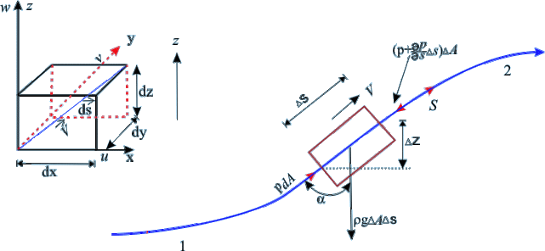
Let,
- dA = Cross-sectional area of the fluid element
- ds = Length of the fluid element
- dW = Weight of the fluid element
- P = Pressure on the element at A
- P+dP = Pressure on the element at B
- v = velocity of the fluid element

The external forces tending to accelerate the fluid element in the direction of the streamline
(1)
We also know that the weight of the fluid element,
The component of the weight of the fluid element in the direction of flow,
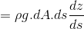
(2)
Mass of the fluid element =
The acceleration of the fluid element
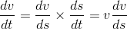 (3)
Now, as per Newton's second law of motion, we know that Force = Mass *Acceleration
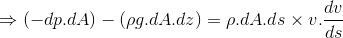
Dividing both sides by
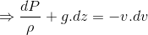
or,
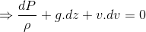 (4)
This is the required Euler's equation for motion as in the form of a differential equation. Integrating the above equation,
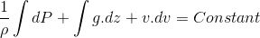
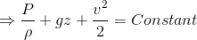
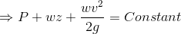
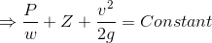
or in other words,
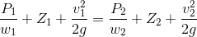
(5)
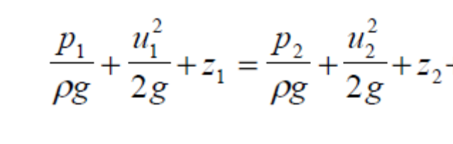 (5)
BERNOULLI EQUATION
The Bernoulli equation shown in (6) above is applicable to network flow through a pipe. The various components of heads e.g pressure, velocity and potential all contribute to the total head expressed as H. The model is an addictive model in which each of the components can be treated individually and also as a group if need be. Generally analysis is done for different points, e.g point 1 on the outlet of a reservoir tank to point 2 at the outlet nozzle of water pump stand. And we know that the total energy per unit weight or the total head does not change i.e it is constant, but we need to determine this value using the Bernoulli equation.

CASE 1 – When the Pipe nozzles are closed (Figure 2)
In figure 2 above, the total head line is shown, and piezometers are attached at points
along the pipe, and measured when the pipe nozzle are closed i.e at point of zero velocity. (Piezometers are simply open ended vertical tubes filled with the same liquid whose pressure they are measuring). The level in the piezometer is the pressure head as shown in bernoulli equation.

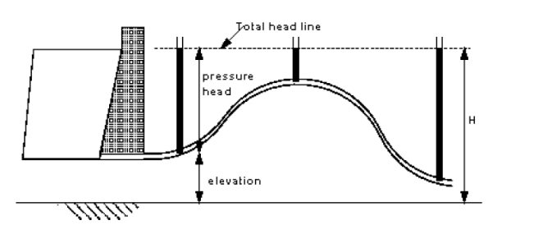

Figure 2: Piezometer Level when the Nozzles are Closed.

Therefore the expected total head for this case 1 is
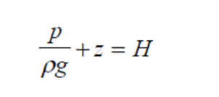 (6)
CASE 2 – When the Pipe nozzles are opend and flow is allowed (Figure 3)

With the nozzles opened, and water flowing with velocity = u, there is the tendency for the pressure to fall while the velocity increases since the total head will remain the same.

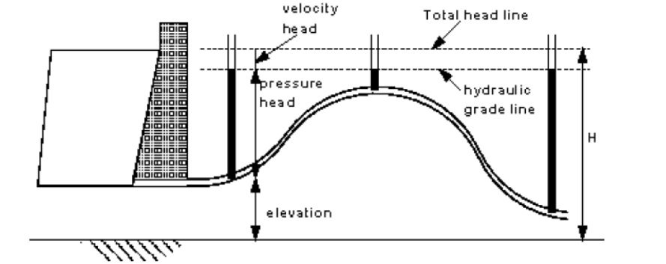
.
Figure 3: Piezometer level when the nozzles are opened.

Therefore the expected total head for this case 2 is
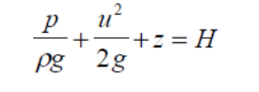 (7)
Therefore from figure 3, the pressure head reduces by an amount equivalent to the velocity head. Since the pipe is of constant diameter, the velocity therefore will be constant along the pipe so the velocity head and is represented graphically by the horizontal line shown. (this line is known as the hydraulic grade line).

CASE 3 – Head Loss Computation (Figure 4)
There are generally energy losses due to friction in a real world order, and must be taken into account. How would the pressure and hydraulic grade lines change with friction? Going back to
the constant diameter pipe, we would have a pressure situation like this shown below.

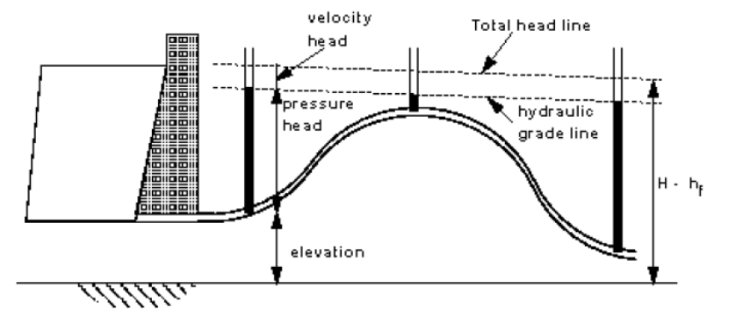
Figure 4: Head losses due to friction
Since head is lost, the total head will therefore not remain constant again.

Continuity Equation

Since water flows through pipes of varying configuration and size, there is every need to apply the continuity equation.
- Matter cannot be created or destroyed - (it is simply changed in to a different form of matter). This principle is know as the conservation of mass and we use it in the analysis of flowing fluids. The principle is applied to fixed volumes, known as control volumes (or surfaces), like that in the figure 5:
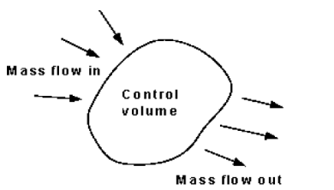
Figure 5: Control Volume
For any control volume the principle of conservation of mass says
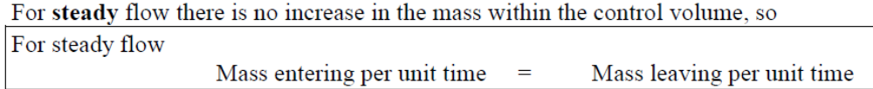

Mass entering per unit time at end 1 = mass leaving per unit time at end 2 = 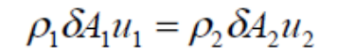 (8)
Assuming a constant density,
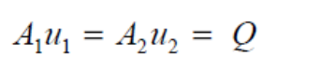 (9)
This is the continuity equation useful for the computation of flow rate Q. the flow rate across different sections is expected to be the same,

Tutorial Examples

Example 1: On a circular conduit there are different diameters: diameter D1 = 2 m changes into D2 = 3 m. The velocity in the entrance profile was measured: v1 = 3 ms-1. Calculate the discharge and mean velocity at the outlet profile (see fig. 1). Determine also type of flow in both conduit profiles (whether the flow is laminar or turbulent) – temperature of water T = 12° C
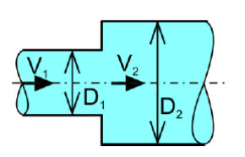
Figure 6: Flow through a pipe network

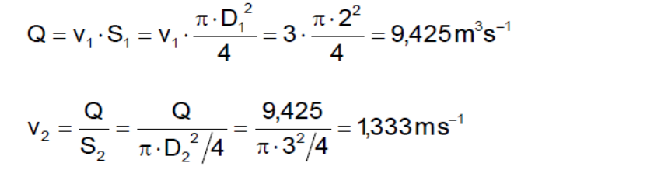
To determine type of flow in conduit, the Reynolds number 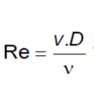will be determined considering the following conditions:

For laminar flow: 2320< Re.
For turbulent flow 2320> Re.

Kinematic viscosity of water of 12°C (Table attached)
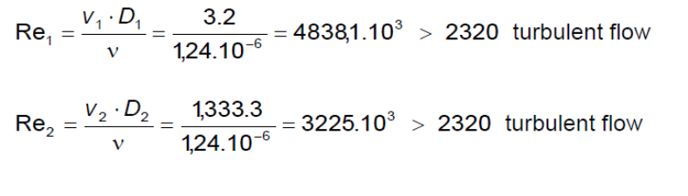
Example 2: A horizontal pipeline is attached to the wall of reservoir (see figure 7). The pipeline has different profiles. The water level in the upper reservoir is in the height H = 1.5 m above the pipeline axis. From the lower end of the pipeline water flows out to the open space. Diameters and lengths of pipeline reaches are: D1 = 0.24 m, L1 = 3 m, D2 = 0.1 m, L2 = 1 m, D3 = 0.12 m, L3 = 2 m. Calculate discharge in the pipeline and draw the course of energy line (EL) and pressure line (PL).
Resolve the problem:
a) Neglecting losses (i.e. consider the liquid to be ideal)
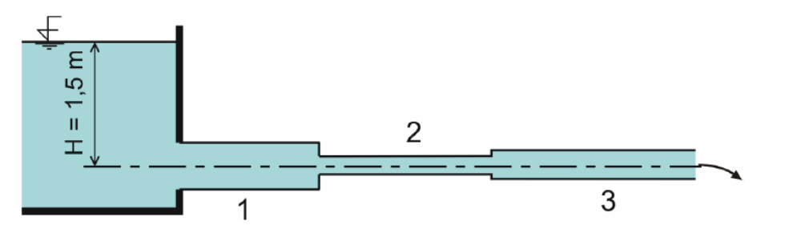
Figure 7:
Bernoulli equation (BE) and continuity equation will be used to solve the problem. Using BE to calculate discharge, it will be the most convenient to state the datum (reference) level at the axis of the horizontal pipe, and to write then BE for the upper water level (profile 0  pressure on the level is known - pa), and for the centre of outlet profile 3 (its position, referred to the datum level, is h = 0). The upper reservoir can be considered to be large (its dimensions are not mentioned because they have no importance) and the effect of approach velocity un can be therefore neglected (i.e. vn = 0).
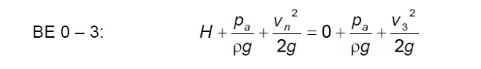
Arranging this equation, mean velocity in outlet profile can be calculated
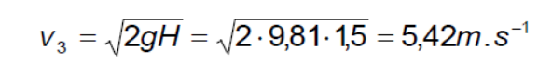
Mass discharge is calculated from continuity equation
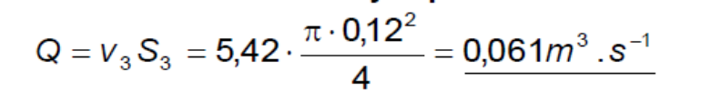
Now it is possible to use continuity equation again, to calculate velocities in other profiles and to calculate thus also corresponding velocity heads.
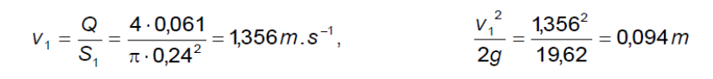
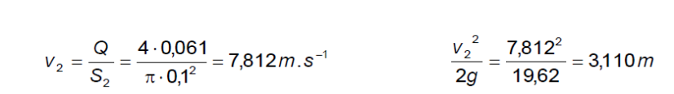
As diameters in the single reaches of the pipeline are constant, also velocities are constant in these reaches. The energy line and pressure line will therefore be parallel and, because of considering the liquid to be ideal, they will be horizontal. Then the BE can be written for 2 profiles - the first one situated at the water level of the upper reservoir, the second one situated e.g. in the middle of length of the first reach of pipe (static pressure there is still unknown):
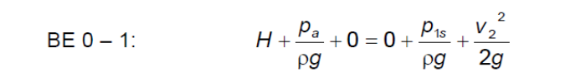
after its rearrangement:
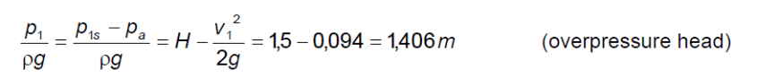
Similarly, for the second reach of the pipeline:
In the outlet profile there is the atmospheric pressure which, in this case, will be also in the whole length of the last pipe reach. Both velocities and pressures are constant in single reaches of pipeline, energy and pressure lines are therefore parallel, as mentioned. In profiles, where the pipe diameters change, the pressure line changes its position suddenly. Energy line and pressure line are seen on figure 8.
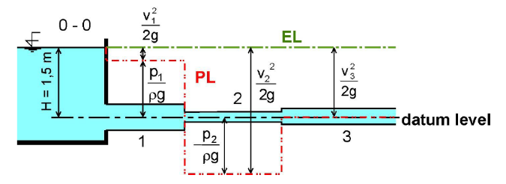
MODELLING – Bulkingham pi Theorem

Thes method is illustrtated with the drag force of a ship floating on water. There are generally 6 quantities namely: Drag (D), Length (L), Pressure (P), Viscousity (V), Velocity (u) and Gravity (G). These are the n no of quantity. There are also the M no of dimensions namely: Mass (M), length (L), and Time (T). These quantities can be reduced to (n-m) independent dimensionless groups such as Re and Fr.

Determining Dimensionless quantities

(10)
are the quantities of Function sign.
Steps
- 1 Forming the group.
For each of the group, take m of the quantities as the repeating variables, and known as M repeating variables, and one of the other remaining variables. Experience shows which quantity makes the best repeating variables. The group in general form could then be:
=

=

=

- Set up the group for MLT system, m=3, i.e MLT, and choose , , and as repeating variables.
Using the bulkingham pi theorem on drag force

M = 3, and n = 6.
So there will be n-m = 3 group.
- Select as repeating variable (RV) and leaving D, U, and G as the non repeating variables.
Note: If the analysis is not workable, new repeating variables can always be selected.

=
=
=
- Which are all dimensionless quantities of
Expanding and collecting like terms we can solve the exponenets
M: 0 = X1 +1 = X1 = -1
T: 0 = Y1 -2 = Y1 =-2
L: 0 = -3(X1) + Y1 + Z1 +1 = Z1 = -2
The exponenets are X1, Y1, Z1, -1, -2, and -2.
The first dimensionless group is obtained by substituting the following back to the equation.
Repeating similar procedure to determine the other groups.

Dimensional Analysis and Similitude

Wind Force on a Van
Suppose you are driving a van down a highway with gusty winds. How does the speed of your vehicle affect the wind force you are experiencing?
The force F of the wind on the van is certainly affected by the speed v of the van and the surface area A of the van directly exposed to the wind's direction. Thus, we might hypothesize that the force is proportional to some power of the speed times some power of the surface area; that is,

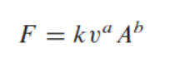
The dimensions of the variables are as shown
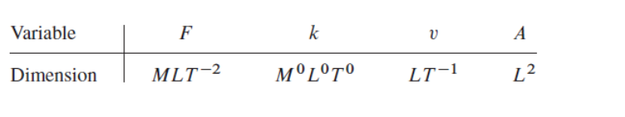
Hence the above equation becomes

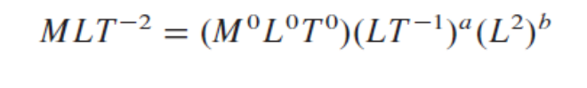
This last equation cannot be correct because the dimensionM for mass does not enter into the right-hand side with nonzero exponent. This can be resolved by including the density factor. If we include the density as a factor, then refine our model becomes

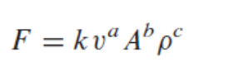
Therefore the equation becomes

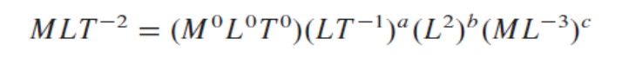
Equating the exponents on both sides of this last equation leads to the system of linear equations:
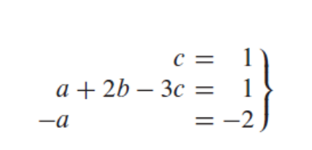
Solution of the system (14.8) give a = 2, b = 1, and c = 1. When substituting these values give the model

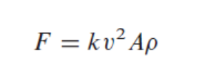
Therefore assuming density to be constant and that:
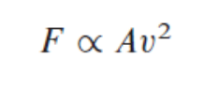
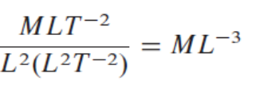

Comparing Dimensional Analysis and Experimental Approach

For a controlled experiment using the Drag Force of a Ship as illustrated above, the following set of experiments will be done.

• Fix 𝐷, 𝜇 and 𝜌. Change 𝑉 and measure 𝐹𝐷.
• Fix 𝑉, 𝜇 and 𝜌. Change 𝐷 and measure 𝐹𝐷.
• Fix 𝐷, 𝑉 and . Change 𝜌 and measure 𝐹𝐷.
• Fix 𝐷, 𝑉 and 𝜌. Change 𝜇 and measure 𝐹𝐷.

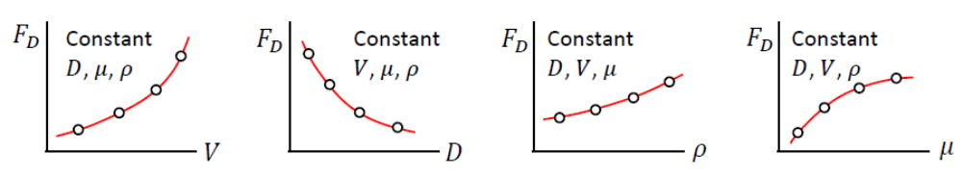
Therefore We need to perform too many experiments.
It is possible to simplify the dependency of drag force on other variables by using nondimensional (unitless) parameters.
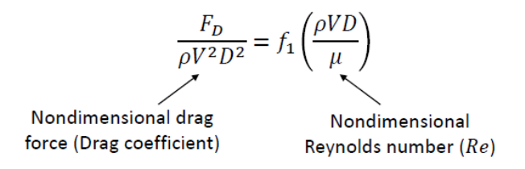

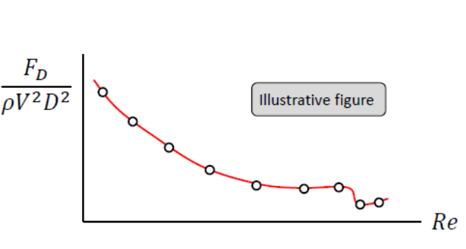
To find this new relation, we only need to change the Reynolds number. We can do it in any way we want, e.g. the simplest way is to change the speed of air flow in a wind tunnel.
This eases the stress of of conducting four different experiments to determine Drag force.

Summary of the Basic steps in dimensional analysis is thus:

- Step 1 : List all the dimensional variables involved in the problem. E.g no of dimensional variables, basic units of dimensions, and the dimensionless pi groups.
- Step 2 : Express each of the variables in tems of basic dimensions, which of 𝐿 : length , 𝑇 : time , 𝑀 : mass. E.g
Variables having only 𝐿 in their dimension are called geometric variables.
Variables having only 𝑇 or both 𝐿 and 𝑇 are called kinematic variables.
Variables having 𝑀 in their dimension are called dynamic variables.
- Step 3: Determine the repeating variables that are allowed to appear in more than one Pi group.There should be 𝑟 many repeating variables.
If 𝐿 is a primary dimension of the problem, we should select one geometric variable as a repeating variable.
If 𝑇 is a primary dimension of the problem, we should select one kinematic variable as a repeating variable.
If 𝑀 is a primary dimension of the problem, we should select one dynamic variable as a repeating variable.

Model and Prototype

In experimental fluid mechanics we sometimes can not work with real sized objects, known as prototypes. Instead we use scaled down (or up) versions of them, called models.
Three Basic Laws of Similitude
Geometric similarity : Model and prototype must be the same in shape, but can be different in size. All linear dimensions of the model be related to corresponding dimensions of the prototype by a constant length ratio, 𝐿𝑟.
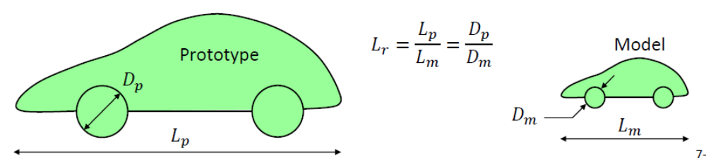
2. Kinematic similarity : Model and prototype flow fields are kinematically similar if the velocities at corresponding points are the same in direction and differ only by a constant factor of velocity ratio, 𝑉𝑟 .
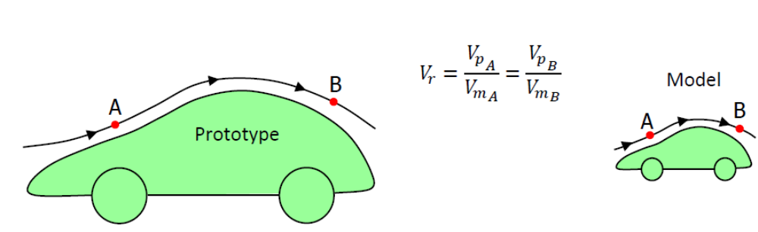
3. Dynamic similarity : Two flow fields should have force distributions such that identical types of forces are parallel and are related in magnitude by a constant factor of force ratio.
If a certain type of force, e.g. compressibility force, is highly dominant in the prototype flow, it should also be dominant in the model flow. How suitable would it be to use a water tunnel to study the aerodynamic forces acting on a supersonic missile ? If a certain type of force, e.g. surface tension force, is negligibly small in the prototype flow, it should also be small in the model flow. How suitable whould it be to use a very light and very small model to test the forces acting on a ship ? To establish dynamic similarity we need to determine the important forces of the prototype flow and make sure that the nondimensional numbers related to those forces are the same in prototype and model flows.

STABILITY OF FLOATING BODIES
A floating body is STABLE if, when it is displaced, it returns to equilibrium.
A floating body is UNSTABLE if, when it is displaced, it moves to a new equilibrium.
Consider a floating body tilted by an angle Δθ, as shown below. For the untilted body the point G is the centre of gravity of the body where the body weight, W, acts. The point B is the centre of buoyancy (the centroid of the displaced volume of fluid) where the upward buoyancy force, F_{B}, acts.
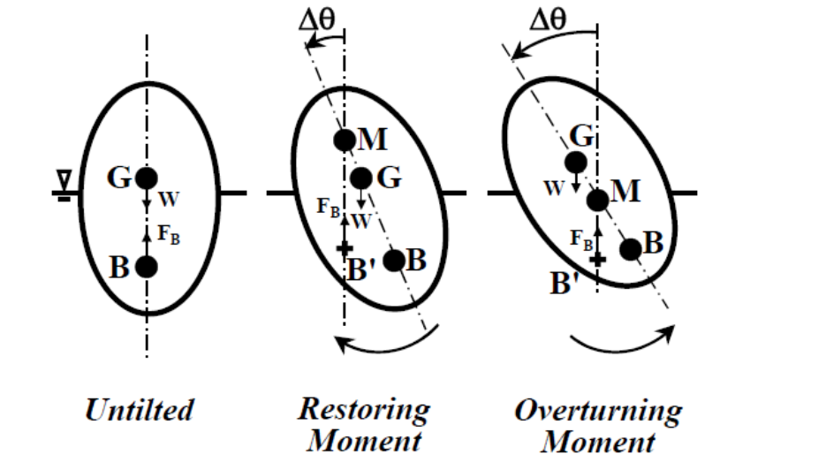
When the body is tilted the centre of buoyancy moves to a new position, B', because the shape of the displaced volume changes. A new point, M, may be defined, called the METACENTRE. This is the point where a vertical line drawn upwards from the new centre of buoyancy, B', of the tilted body intersects the line of symmetry of the body. The buoyancy force, F_{B}, now acts through B'.
From the centre diagram in the figure we can see that W and F_{B} give a RESTORING MOMENT that rotates the body back to its untilted position. From the right hand diagram in the figure we can see that W and F_{B} give an OVERTURNING MOMENT that rotates the body even further in the tilted direction.
Hence, we can say; if the metacentre, M, lies above the centre of gravity, G, then the body is stable. In other words the METACENTRIC HEIGHT, MG, is positive (MG = z_{M} - z_{G} > 0). If the metacentre, M, lies below the centre of gravity, G, then the body is unstable. In other words the metacentric height, MG, is negative (MG < 0).
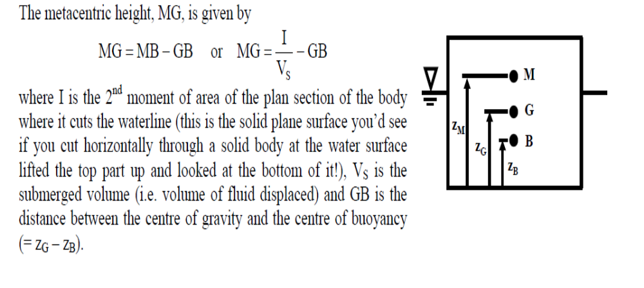
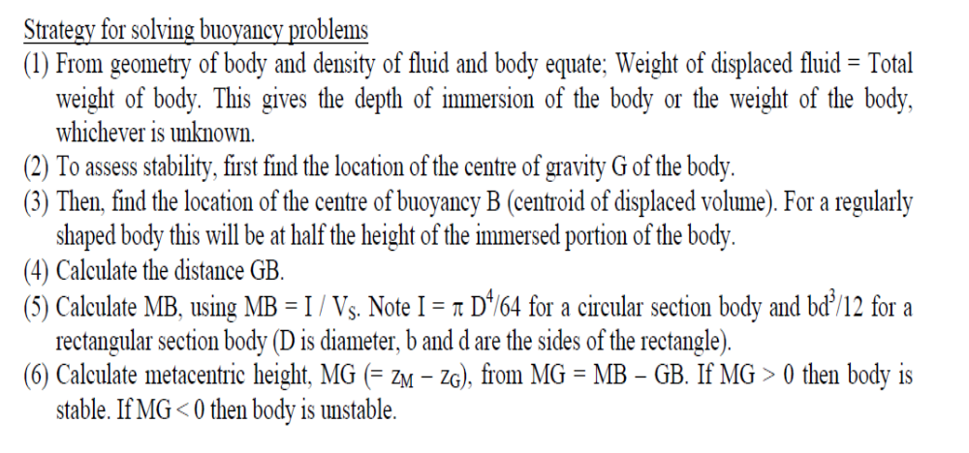
Buoyancy
PRINCIPLES

- Buoyance:It is an upward thrust exerted by a liquid on a body floatingor immersed in it.It is equal to the weight of the liquiddisplaced by the body.
- Archimedies Principle: Whenever a body immersed wholly or partially in a liquidit is acted upon by a vertical upward liquid thrust equal tothe weight of the liquid displaced.
- Center of Buoyancy: It is the point at which the buoyancy or upward liquidthrust acts. The centre of buoyancy will be the centre of gravity of the fluid displaced.
When a solid object is wholly or partly immersed in a fluid, the fluid molecules are continually striking the submerged surface of the object. The forces due to these impacts can be combined into a single force the buoyant force. The immersed object will be “lighter” i.e. It will be buoyed up by an amount equal to the weight of the fluid it displaces.
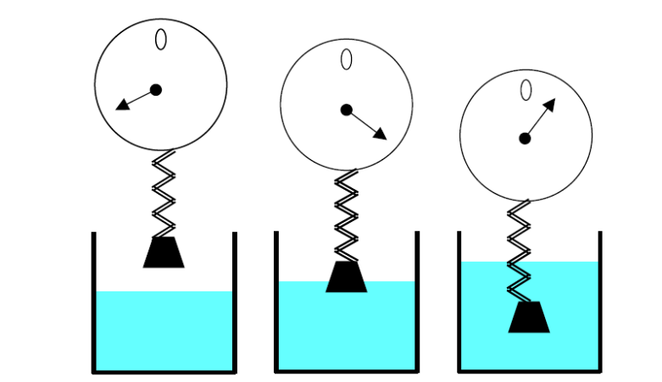
Floating: partially submerged
- Weight of object < weight of fluid that can be displaced by object.
- Volume of displaced water < volume of object.
- Weight of liquid displaced by partially submerged object = weight of object Water
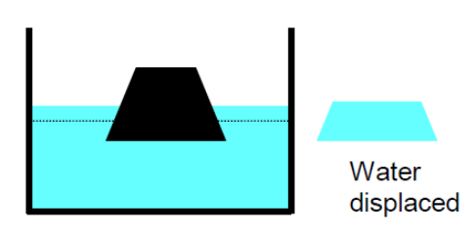

Floating: fully submerged
- Weight of object = weight of fluid displaced by object.
- Volume of displaced water = volume of object
Sinks
- Weight of object > weight of fluid displaced by object.
- Volume of displaced water = volume of object.
Pressure in a liquid
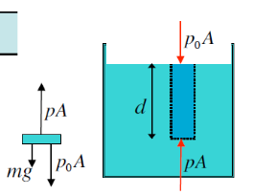

Atmospheric pressure p0 pushes down with force of p0A. The weight of the column pushes down with force mg. For a liquid with density ρ, m=ρV=ρAd.
Because the liquid is in static equilibrium, the up
Some rules for pressure
Pascal’s law: A pressure change at one point in an incompressible fluid appears undiminished at all points in the fluid. A force F is applied to a piston of area A, increasing the pressure by F/A.
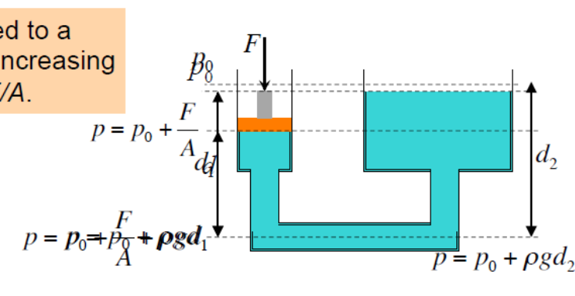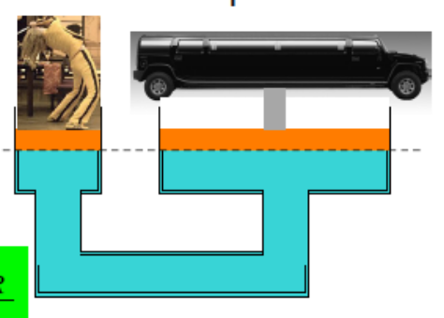

Tutorial examples using the manual Titled - Buoyancy and Flotation Tutorial Example. This material is a compilation of various examples.

